# NOTEBOOK 2

**NETAJI SUBHASH INSTITUTE OF TECHNOLOGY, NEW DELHI**

Sarthak Tandon, Mansi Breja

# ABSTRACT

The objective of this notebook was to put to application the basics of the design of digital systems on Arduino (open-hardware) that we learnt in the previous notebook numbered 1.

We learned to connect the Arduino with external input and output peripherals, obtained a higher-level system, learned about sensors, buzzers, LEDs, transistors and the like.

We learned to assemble the basic constituents into a real time application which in this case was a SMART TRAFFIC LIGHT SYSTEM.

# TOOLS WE USED

The programs were supposed to be understood and tested by us. The best way to understand a piece of code is to rewrite it and test it on our own. TINKERCAD simulator was used by our team to test and run the programs. TINKERCAD is an online simulator powered by AUTODESK. Tinkercad is an easy, browser-based 3D design and modelling tool for all. Tinkercad allows users to imagine anything andthen design it in minutes.

# SMART TRAFFIC LIGHT SYSTEM

# Our Design

***This circuit uses the following components on Tinkercad:***

-Arduino

-Breadboard

-LEDs

-Buzzer

-Resistances

***The code that simulates this is:***

//SMART TRAFFIC LIGHT CODE BEGINS

//Traffic signal

int green=2;

int yellow=8;

int blue=7;

int red=12;

int inpin=4;

int buzzpin=5;

int val=0;

int length=15;

char notes[]= "ccggaagffeeddc";

int beats[]={1,1,1,1,1,1,2,1,1,1,1,1,1,2,4};

int tempo=300;

void playTone(int tones, int duration)

{

for (long i=0; i < duration*1000; i+=tones*2);

{

tone(buzzpin,tones, duration);

}

}

void playNote(char note, int duration)

{

char names[]= {'c', 'd', 'e', 'f', 'g', 'a', 'b', 'C'};

int tones[]={1915, 1700, 1519, 1432, 1275, 1136, 1014, 956};

for (int i=0; i < 8; i++)

{

if (names[i]==note)

{

playTone(tones[i], duration);

}

}

}

void setup()

{

Serial.begin(9600);

pinMode(green, OUTPUT);

pinMode(yellow, OUTPUT);

pinMode(red, OUTPUT);

pinMode(blue, OUTPUT);

pinMode(inpin, INPUT);

pinMode(buzzpin, INPUT);

}

void loop()

{

digitalWrite(green,1);

val= digitalRead(inpin);

Serial.println(val);

if (val==1)

{

delay(2000);

digitalWrite(green, 0);

digitalWrite(blue, 1);

for (int i=0; i < 5;i++)

{

digitalWrite(yellow, 1);

delay(500);

digitalWrite(yellow, 0);

delay(500);

}

digitalWrite(yellow, 1);

delay(4000);

digitalWrite(yellow, 0);

digitalWrite(blue, 0);

digitalWrite(red, 1);

delay(4000);

digitalWrite(red, 0);

for (int i=0; i < length; i++)

{

if (notes[i]==' ')

{

delay(beats[i]*tempo);

}

else

{

playNote(notes[i], beats[i]*tempo);

}

delay(tempo/2);

}

delay(1000);

}

}

//CODE ENDS

**The screen shots from Tinker cad for the same are:**

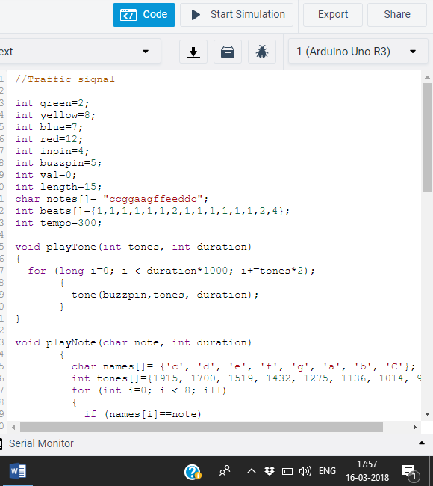

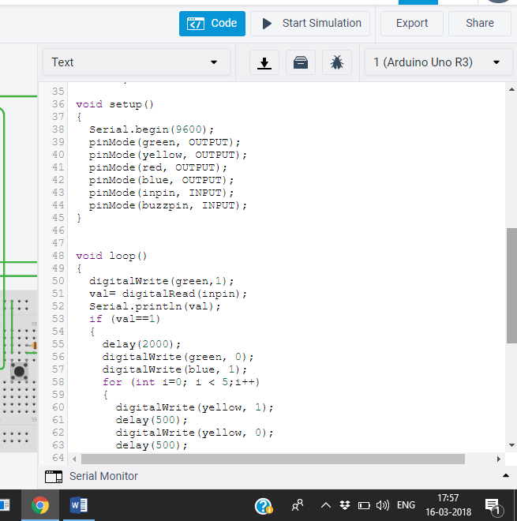

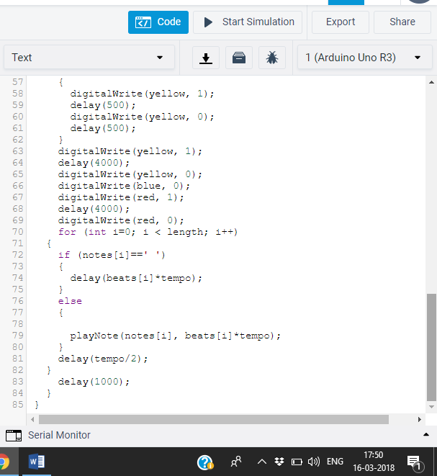

# **SEE IT WORK**

<https://drive.google.com/file/d/1pSxfFzTeuZv5twCkcNzNVD76c3ZNhaJ1/view?usp=sharing>

# **TIME DEVOTED BY EACH GROUP MEMBER**

**Sarthak Tandon:** 1.5 hours

**Mansi Breja:** 1.5 hours

# **CONCLUSION**

The assigned task of designing a Smart Traffic Light System gave us an opportunity to go beyond our way and increase our familiarisation with the in depth functionality of Arduino circuitry using simulators like Tinkercad. The team developed a deeper understanding of making circuits using Arduino components and controlling them.

The document provided to us was very informative, and it guided us wonderfully throughout the project completion. Our professor, Dr. Pinaki Chakraborty helped us in all possible ways and guided us throughout.

Our basic knowledge of the programming languages of C/C++ also helped us in accomplishing this task and in due course, we only learned both electronics and programming better.